"Ice Melt"
Teacher

Introduction

Most metals are excellent conductors of electricity. A common metal like copper is used to make the wires for electric cords and speakers. Other common materials like wood and plastic are great insulators. The handle of screwdriver can be made of wood or plastic, which may help reduce the chance of an electric shock if the metal end of the screwdriver touches a charged wire.
In today's lab, you will test whether the heat conductibility of three separate materials is similar to their electrical conductibility. The materials tested are very common and used to make a variety of household items that we use every day. The three materials that will be tested are metal, plastic and wood.

Materials (Note: Many scientific supply companies like Ward's Natural Science sell density cubes which work well for the following lab. The following items also can be purchased at a lumberyard or hardware store.)
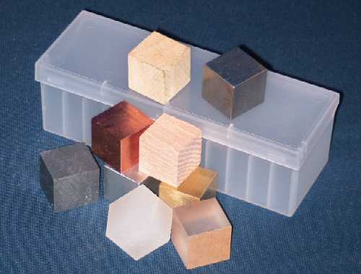
1 Piece of metal
1 Piece of wood
1 Piece of plastic
3 Cubes of ice (may need more for retesting)
1 Stopwatch or clock with second hand
3 Styrofoam plates (runoff of water)
1 Ruler (metric)

Data Table #1 The following samples should be described in detail. (Will vary)

Sample  (material) | Length (cm) | Width (cm) | Height (cm) | Volume (cm³) | Mass  (g) | Density  (g/cm³)
1.
Metal
2.
Wood
3.
Plastic

Process
Data Table #1
1. Describe each of the three samples (column #1).
2. Measure and enter the length, width and height of each sample (cm).
3. Calculate the volume of each sample (L x W x H).
Answers will vary depending on samples.
4. Measure the mass of each sample (g).
5. Calculate the density of each sample (mass/volume).
Answers will vary depending on samples.
6. Place each of the samples on a Styrofoam plate (use an insulated glove or tongs to transfer the samples).
7. Place a cube of ice on each of the samples – you may need to steady the ice (used an insulated glove or tongs to transfer the ice).
8. Make an initial observation and record on table #2; make eight additional observations (see time schedule below).

Data Table #2 Answers will vary – encourage detail (examples: rate of melt, amount of liquid water, temperature of sample, etc.)
Observation | Sample #1 | Sample #2 | Sample #3
Initial
1 (min)
3 (min)
5 (min)
7 (min)
9 (min)
11 (min)
13 (min)
15 (min)

9. Remove the ice from each of the samples. Note any observations below. (Also - note any temperature change in each of the samples.) Encourage detailed observations. Students could observe items like the temperature of the water runoff, the amount of liquid water, the amount of ice remaining, the temperature of the 3 samples, etc.
10. Clean your testing area in accordance to your teacher discretion.

Data analysis (Questions)

1. Why should a gloved hand or tongs be used to transfer the ice and samples during the initial setup? Heat from your hand could raise the temperature of the metal, wood and plastic, affecting the results from one station to the next. Heat also could be transferred to the ice, affecting the results. The students should realize handling the ice or sample is a variable that should be controlled.

2. Which sample had the greatest density? The metal sample should have the greatest density.
3.
a. Rank the following items from greatest to least on the ability to melt ice, cube of plastic, cube of metal, cube of wood The metal should be listed first. The order of the plastic and wood may vary a little depending on the sample you use. You may also notice unusual results if there is a large difference in the thickness of the samples used. This is why the density blocks work great because their volumes are almost identical.
b. Can you provide an explanation for your observations? The metal should have the greatest transfer of heat because of its high density and conductibility. The metal has the greatest number of atoms in contact with the ice and it is a great conductor so heat transfers at a high rate into the ice.
4. Did you notice a change in the rate at which the ice melted as additional observations were made? (why) The rate at which the ice melts will slow as the heat is being transferred from the samples, You should notice a noticeable drop in temperature of the samples, especially the metal sample.
5. Most metals are excellent conductors of electricity. Other common materials like wood and plastic are great insulators. From your observations, do you feel the heat conductibility of three separate materials are similar to their electrical conductibility? (Explain) The students should observe that the metal cube transferred or conducted the greatest amout of heat. The ice in contact with the metal should be melted the most and the metal cube should be the coldest because the heat was transferred out of it at the highest rate.
In the house - extension question
1. When a person removes a turkey from the oven, why can the metal aluminum foil covering the turkey be touched but the metal roaster pan can not be touched because it is to hot? Aluminum foil is designed with two separate finishes. The exterior of the foil is shinny, reflecting the heat from within the oven. As a result the top of the food will not burn before the inside of the meat is cooked completely. The interior of the foil is darker, absorbing some the heat from within, warming up slowly as the food cooks. This temperature separation maintains a moderate cooking environment without the extreme changes. Also, the foil is extremely thin so it will cool very quickly once removed. Teacher demo - A piece of foil can be heated with a flame and touched within seconds once it is removed. The same piece of foil can be rolled in a ball and tested again. The rolled ball of foil will retain heat for an extended period of time.

